Dokumentace SPI_NEWS
Pavel Šesták
16.5.2020

Použité komponenty:

SPI_NEWS
Hlavní entita v projektu, v rámci které je instanciován ovladač SPI řadiče, tři čítače s různými frekvencemi pro změnu rychlosti posuvu textu a 8*16 instancí komponenty cell, reprezentujici jeden pixel na maticovém displeji. Komponenta také řeší přepínání rychlostí a výchozího stavu buněk.
Vstupy a výstupy komponenty:
CLK : in STD_LOGIC – Hodinový signál
RESET : in STD_LOGIC – Reset, pro resetování nutno přivést log. 1
SPI_IN : in STD_LOGIC – Vstup pro zadání příkazu
SPI_EN : in STD_LOGIC – Enable signál pro SPI
SPI_OUT : out STD_LOGIC – Výstup SPI, sloužící pro předání stavu buněk

Counter
Komponenta obdrží dva generické parametry, vstupní a požadovanou výstupní frekvenci. Komponenta zapne výstupní signál jednou za požadovaný počet taktů, slouží pro posun textu na displeji. V rámci hlavní entity existují signály EN, EN1k,EN2k a EN3k. EN1k,EN2k a EN3k jsou výstupy z čítačů rozlišené pomocí výstupní frekvence, EN je signál podle kterého jsou řízeny buňky a tento signál je volen z výstupů čítačů pomocí SPI controleru.
Generické parametry:
CLK_FREQ : positive – Frekvence hodin
OUT_FREQ : positive – Požadovaná výstupní frekvence
Vstupy a výstupy komponenty:
CLK : in STD_LOGIC – Hodinový signál
RESET : in STD_LOGIC – Reset, pro resetování nutno přivést log. 1
EN : out STD_LOGIC – Enable signál sloužící pro posuv buněk.

spi_ctrl
Ovladač SPI řadiče, přes který jsou celé světelné noviny ovládány. Pro zahájení komunikace je třeba aktivní SPI_EN signál.
Vstupy a výstupy komponenty:
CLK : in STD_LOGIC – Hodinový signál
RESET : in STD_LOGIC – Reset, pro resetování nutno přivést log. 1
SPI_IN : in STD_LOGIC – Bit přes který je příjmán 8 bitový kód posílán od LSB
SPI_EN : in STD_LOGIC – Bit, který je nutný pro povolení komunikace, mezi každým příkazem musí dojít k nastavení bitu na 0
SPI_OUT : out STD_LOGIC – Bit přes který řadič posílá odpověď od LSB
DIRECTION : out DIRECTION_T – nastavení směru posuvu textu
INIT_STATE : out STD_LOGIC_VECTOR(1 downto 0) – Volba výchozího stavu displeje
CELL_RESET : out STD_LOGIC - Signál sloužící pro přechod buňek do výchozího stavu
SPEED : out STD_LOGIC_VECTOR(1 downto 0) – Volba rychlosti posuvu displeje
STATES : in STD_LOGIC_VECTOR(127 downto 0) – Vektor obsahující aktuální stav buněk

cell
Komponenta reprezentující jeden pixel, obsahuje svůj aktuální stav a stav svých sousedů, který přebírá v závislosti na směru posuvu.

Vstupy a výstupy komponenty:
CLK : in STD_LOGIC – Hodinový signál
RESET : in STD_LOGIC - Reset, pro resetování nutno přivést log. 1
STATE : out STD_LOGIC – bit reprezentující aktuální stav, provázán s konkrétním bitem ve vektoru STATES
INIT_STATE : in STD_LOGIC – bit reprezentující konkrétní bit v rámci vektoru, který je zvolen jako aktuální výchozí stav
NEIGH_LEFT : in STD_LOGIC – bit uchovávájící stav souseda vlevo
NEIGH_RIGHT : in STD_LOGIC - bit uchovávájící stav souseda vpravo
DIRECTION : in DIRECTION_T – informace ohledně směru posuvu
EN : in STD_LOGIC – Enable signál z aktuálně zvoleného čítače

Výchozí stavy buněk
Projekt obsahuje čtyři výchozí stavy, a a jeden signál pro aktuálně zvolený stav. Aktuální stav se volí pomocí SPI řadiče. Výchozí stavy a jednotlivé bity jsou znázorněny na obrázku pod názvem stavu:

INIT_STATE_00
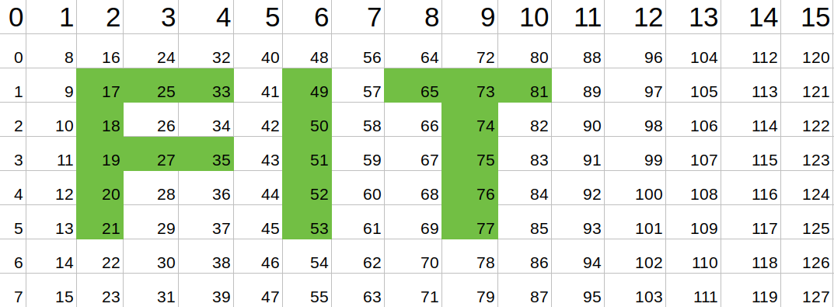

INIT_STATE_01
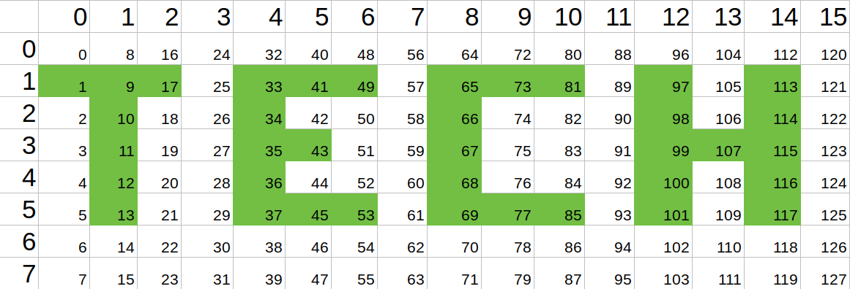

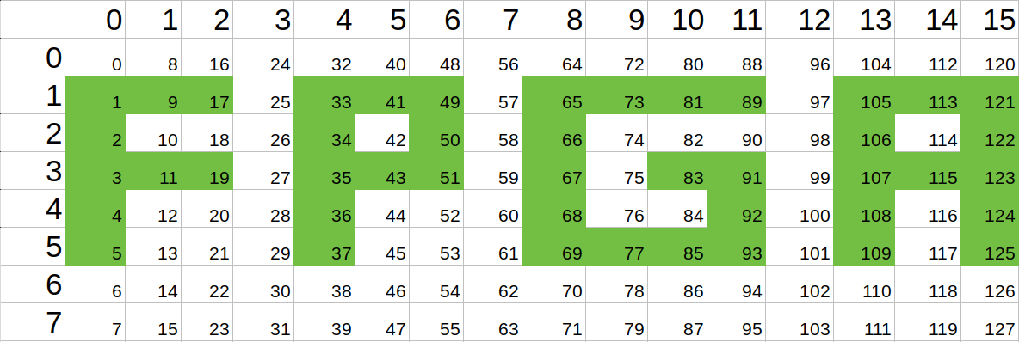
INIT_STATE_10

INIT_STATE_11

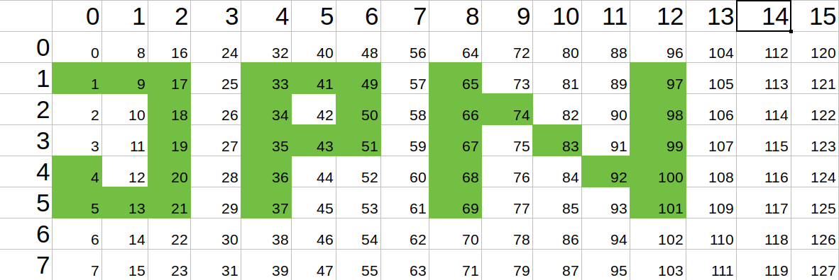
Testbench
K hlavní komponentě SPI_NEWS byl vytvořen testbench, jehož výstup bude následně popsán.
V rámci testbenche bylo zavedeno:

Konstanty:
constant C1K_period : time := 1000*CLK_period - Perioda čítače s výstupní frekvencí 1K

constant C2K_period : time := 500*CLK_period - Perioda čítače s výstupní frekvencí 2K

constant C5K_period : time := 200*CLK_period – Perioda čítače s výstupní frekvencí 5K

constant READING_MATRIX_TIME : time := 272*CLK_period - Doba nutná pro vypsání stavu displeje

Procedury:

PROCEDURE SendCommand(CMD : in STD_LOGIC_VECTOR(7 downto 0);
signal SPI_IN : out STD_LOGIC) is

Procedura slouží pro komunikaci s SPI controlerem pomocí 8 bitových příkazů.
Procedura bere dva parametry, první bere příkaz, který bude poslán SPI controleru, a druhý signál SPI_IN, na který bude posílat jednotlivé bity příkazu.

PROCEDURE ReadMatrix( signal SPI_IN : out STD_LOGIC;
signal SPI_OUT : in STD_LOGIC;
signal SPI_EN : out STD_LOGIC) is

Procedura slouží pro vyčtení aktuálního stavu buněk.
Procedura bere tři parametry, v prvním očekává signál SPI_IN přes který bude posílat příkazy pomocí procedury SendCommand. Druhý parametr vyžaduje SPI_OUT přes který bude zaznamenávat odpověď controleru a ukládát si stav do proměnné. Třetí parametr obsahuje signál SPI_EN aby bylo možné ovládat povolení komunikace s řadičem.
Výsledek je vypsán pomocí reportu do logu testování

Výstup simulace

Výstup

Version:1.0 StartHTML:0000000105 EndHTML:0000063503 StartFragment:0000000538 EndFragment:0000063467

ISim O.40d (signature 0x79f3f3a8)

WARNING: A WEBPACK license was found.

WARNING: Please use Xilinx License Configuration Manager to check out a full ISim license.

WARNING: ISim will run in Lite mode. Please refer to the ISim documentation for more information on the differences between the Lite and the Full version.

This is a Lite version of ISim.

Time resolution is 1 ps

Simulator is doing circuit initialization process.

Finished circuit initialization process.

Test inicializace konstant
Test zkouší nastavit defaultní konstanty a následně je vypíše.

at 1120 ps: Note: setting init_state_01 with text TECH (/spi_news_tb/).

at 1210 ps: Note: Reading matrix (/spi_news_tb/).

at 3930 ps: Note: '0''0''0''0''0''0''0''0''0''0''0''0''0''0''0''0' (/spi_news_tb/).

at 3930 ps: Note: '0''0''0''0''0''0''0''0''0''0''0''0''0''0''0''0' (/spi_news_tb/).

at 3930 ps: Note: '1''1''1''0''1''1''1''0''1''1''1''0''1''0''1''0' (/spi_news_tb/).

at 3930 ps: Note: '0''1''0''0''1''0''0''0''1''0''0''0''1''0''1''0' (/spi_news_tb/).

at 3930 ps: Note: '0''1''0''0''1''1''0''0''1''0''0''0''1''1''1''0' (/spi_news_tb/).

at 3930 ps: Note: '0''1''0''0''1''0''0''0''1''0''0''0''1''0''1''0' (/spi_news_tb/).

at 3930 ps: Note: '0''1''0''0''1''1''1''0''1''1''1''0''1''0''1''0' (/spi_news_tb/).

at 3930 ps: Note: '0''0''0''0''0''0''0''0''0''0''0''0''0''0''0''0' (/spi_news_tb/).

at 3930 ps: Note: setting init_state_11 with text JPN (/spi_news_tb/).

at 4020 ps: Note: Reading matrix (/spi_news_tb/).

at 6740 ps: Note: '0''0''0''0''0''0''0''0''0''0''0''0''0''0''0''0' (/spi_news_tb/).

at 6740 ps: Note: '0''0''0''0''0''0''0''0''0''0''0''0''0''0''0''0' (/spi_news_tb/).

at 6740 ps: Note: '1''1''1''0''1''1''1''0''1''0''0''0''1''0''0''0' (/spi_news_tb/).

at 6740 ps: Note: '0''0''1''0''1''0''1''0''1''1''0''0''1''0''0''0' (/spi_news_tb/).

at 6740 ps: Note: '0''0''1''0''1''1''1''0''1''0''1''0''1''0''0''0' (/spi_news_tb/).

at 6740 ps: Note: '1''0''1''0''1''0''0''0''1''0''0''1''1''0''0''0' (/spi_news_tb/).

at 6740 ps: Note: '1''1''1''0''1''0''0''0''1''0''0''0''1''0''0''0' (/spi_news_tb/).

at 6740 ps: Note: '0''0''0''0''0''0''0''0''0''0''0''0''0''0''0''0' (/spi_news_tb/).

at 6740 ps: Note: setting init_state_10 with text FPGA (/spi_news_tb/).

at 6830 ps: Note: Reading matrix (/spi_news_tb/).

at 9550 ps: Note: '0''0''0''0''0''0''0''0''0''0''0''0''0''0''0''0' (/spi_news_tb/).

at 9550 ps: Note: '0''0''0''0''0''0''0''0''0''0''0''0''0''0''0''0' (/spi_news_tb/).

at 9550 ps: Note: '1''1''1''0''1''1''1''0''1''1''1''1''0''1''1''1' (/spi_news_tb/).

at 9550 ps: Note: '1''0''0''0''1''0''1''0''1''0''0''0''0''1''0''1' (/spi_news_tb/).

at 9550 ps: Note: '1''1''1''0''1''1''1''0''1''0''1''1''0''1''1''1' (/spi_news_tb/).

at 9550 ps: Note: '1''0''0''0''1''0''0''0''1''0''0''1''0''1''0''1' (/spi_news_tb/).

at 9550 ps: Note: '1''0''0''0''1''0''0''0''1''1''1''1''0''1''0''1' (/spi_news_tb/).

at 9550 ps: Note: '0''0''0''0''0''0''0''0''0''0''0''0''0''0''0''0' (/spi_news_tb/).

at 9580 ps: Note: Reading matrix (/spi_news_tb/).

at 12300 ps: Note: '0''0''0''0''0''0''0''0''0''0''0''0''0''0''0''0' (/spi_news_tb/).

at 12300 ps: Note: '0''0''0''0''0''0''0''0''0''0''0''0''0''0''0''0' (/spi_news_tb/).

at 12300 ps: Note: '0''0''1''1''1''0''1''0''1''1''1''0''0''0''0''0' (/spi_news_tb/).

at 12300 ps: Note: '0''0''1''0''0''0''1''0''0''1''0''0''0''0''0''0' (/spi_news_tb/).

at 12300 ps: Note: '0''0''1''1''1''0''1''0''0''1''0''0''0''0''0''0' (/spi_news_tb/).

at 12300 ps: Note: '0''0''1''0''0''0''1''0''0''1''0''0''0''0''0''0' (/spi_news_tb/).

at 12300 ps: Note: '0''0''1''0''0''0''1''0''0''1''0''0''0''0''0''0' (/spi_news_tb/).

at 12300 ps: Note: '0''0''0''0''0''0''0''0''0''0''0''0''0''0''0''0' (/spi_news_tb/).

Test posuvu displeje vlevo

Frekvence 1k

at 12310 ps: Note: setting speed to 00 (/spi_news_tb/).

at 12390 ps: Note: Reading matrix (/spi_news_tb/).

at 15110 ps: Note: '0''0''0''0''0''0''0''0''0''0''0''0''0''0''0''0' (/spi_news_tb/).

at 15110 ps: Note: '0''0''0''0''0''0''0''0''0''0''0''0''0''0''0''0' (/spi_news_tb/).

at 15110 ps: Note: '0''0''1''1''1''0''1''0''1''1''1''0''0''0''0''0' (/spi_news_tb/).

at 15110 ps: Note: '0''0''1''0''0''0''1''0''0''1''0''0''0''0''0''0' (/spi_news_tb/).

at 15110 ps: Note: '0''0''1''1''1''0''1''0''0''1''0''0''0''0''0''0' (/spi_news_tb/).

at 15110 ps: Note: '0''0''1''0''0''0''1''0''0''1''0''0''0''0''0''0' (/spi_news_tb/).

at 15110 ps: Note: '0''0''1''0''0''0''1''0''0''1''0''0''0''0''0''0' (/spi_news_tb/).

at 15110 ps: Note: '0''0''0''0''0''0''0''0''0''0''0''0''0''0''0''0' (/spi_news_tb/).

at 22390 ps: Note: Reading matrix (/spi_news_tb/).

at 25110 ps: Note: '0''0''0''0''0''0''0''0''0''0''0''0''0''0''0''0' (/spi_news_tb/).

at 25110 ps: Note: '0''0''0''0''0''0''0''0''0''0''0''0''0''0''0''0' (/spi_news_tb/).

at 25110 ps: Note: '0''1''1''1''0''1''0''1''1''1''0''0''0''0''0''0' (/spi_news_tb/).

at 25110 ps: Note: '0''1''0''0''0''1''0''0''1''0''0''0''0''0''0''0' (/spi_news_tb/).

at 25110 ps: Note: '0''1''1''1''0''1''0''0''1''0''0''0''0''0''0''0' (/spi_news_tb/).

at 25110 ps: Note: '0''1''0''0''0''1''0''0''1''0''0''0''0''0''0''0' (/spi_news_tb/).

at 25110 ps: Note: '0''1''0''0''0''1''0''0''1''0''0''0''0''0''0''0' (/spi_news_tb/).

at 25110 ps: Note: '0''0''0''0''0''0''0''0''0''0''0''0''0''0''0''0' (/spi_news_tb/).

at 32390 ps: Note: Reading matrix (/spi_news_tb/).

at 35110 ps: Note: '0''0''0''0''0''0''0''0''0''0''0''0''0''0''0''0' (/spi_news_tb/).

at 35110 ps: Note: '0''0''0''0''0''0''0''0''0''0''0''0''0''0''0''0' (/spi_news_tb/).

at 35110 ps: Note: '1''1''1''0''1''0''1''1''1''0''0''0''0''0''0''0' (/spi_news_tb/).

at 35110 ps: Note: '1''0''0''0''1''0''0''1''0''0''0''0''0''0''0''0' (/spi_news_tb/).

at 35110 ps: Note: '1''1''1''0''1''0''0''1''0''0''0''0''0''0''0''0' (/spi_news_tb/).

at 35110 ps: Note: '1''0''0''0''1''0''0''1''0''0''0''0''0''0''0''0' (/spi_news_tb/).

at 35110 ps: Note: '1''0''0''0''1''0''0''1''0''0''0''0''0''0''0''0' (/spi_news_tb/).

at 35110 ps: Note: '0''0''0''0''0''0''0''0''0''0''0''0''0''0''0''0' (/spi_news_tb/).

at 42390 ps: Note: Reading matrix (/spi_news_tb/).

at 45110 ps: Note: '0''0''0''0''0''0''0''0''0''0''0''0''0''0''0''0' (/spi_news_tb/).

at 45110 ps: Note: '0''0''0''0''0''0''0''0''0''0''0''0''0''0''0''0' (/spi_news_tb/).

at 45110 ps: Note: '1''1''0''1''0''1''1''1''0''0''0''0''0''0''0''1' (/spi_news_tb/).

at 45110 ps: Note: '0''0''0''1''0''0''1''0''0''0''0''0''0''0''0''1' (/spi_news_tb/).

at 45110 ps: Note: '1''1''0''1''0''0''1''0''0''0''0''0''0''0''0''1' (/spi_news_tb/).

at 45110 ps: Note: '0''0''0''1''0''0''1''0''0''0''0''0''0''0''0''1' (/spi_news_tb/).

at 45110 ps: Note: '0''0''0''1''0''0''1''0''0''0''0''0''0''0''0''1' (/spi_news_tb/).

at 45110 ps: Note: '0''0''0''0''0''0''0''0''0''0''0''0''0''0''0''0' (/spi_news_tb/).

Frekvence 2k

at 45140 ps: Note: setting speed to 01 (/spi_news_tb/).

at 45220 ps: Note: Reading matrix (/spi_news_tb/).

at 47940 ps: Note: '0''0''0''0''0''0''0''0''0''0''0''0''0''0''0''0' (/spi_news_tb/).

at 47940 ps: Note: '0''0''0''0''0''0''0''0''0''0''0''0''0''0''0''0' (/spi_news_tb/).

at 47940 ps: Note: '0''0''1''1''1''0''1''0''1''1''1''0''0''0''0''0' (/spi_news_tb/).

at 47940 ps: Note: '0''0''1''0''0''0''1''0''0''1''0''0''0''0''0''0' (/spi_news_tb/).

at 47940 ps: Note: '0''0''1''1''1''0''1''0''0''1''0''0''0''0''0''0' (/spi_news_tb/).

at 47940 ps: Note: '0''0''1''0''0''0''1''0''0''1''0''0''0''0''0''0' (/spi_news_tb/).

at 47940 ps: Note: '0''0''1''0''0''0''1''0''0''1''0''0''0''0''0''0' (/spi_news_tb/).

at 47940 ps: Note: '0''0''0''0''0''0''0''0''0''0''0''0''0''0''0''0' (/spi_news_tb/).

at 50220 ps: Note: Reading matrix (/spi_news_tb/).

at 52940 ps: Note: '0''0''0''0''0''0''0''0''0''0''0''0''0''0''0''0' (/spi_news_tb/).

at 52940 ps: Note: '0''0''0''0''0''0''0''0''0''0''0''0''0''0''0''0' (/spi_news_tb/).

at 52940 ps: Note: '0''1''1''1''0''1''0''1''1''1''0''0''0''0''0''0' (/spi_news_tb/).

at 52940 ps: Note: '0''1''0''0''0''1''0''0''1''0''0''0''0''0''0''0' (/spi_news_tb/).

at 52940 ps: Note: '0''1''1''1''0''1''0''0''1''0''0''0''0''0''0''0' (/spi_news_tb/).

at 52940 ps: Note: '0''1''0''0''0''1''0''0''1''0''0''0''0''0''0''0' (/spi_news_tb/).

at 52940 ps: Note: '0''1''0''0''0''1''0''0''1''0''0''0''0''0''0''0' (/spi_news_tb/).

at 52940 ps: Note: '0''0''0''0''0''0''0''0''0''0''0''0''0''0''0''0' (/spi_news_tb/).

at 55220 ps: Note: Reading matrix (/spi_news_tb/).

at 57940 ps: Note: '0''0''0''0''0''0''0''0''0''0''0''0''0''0''0''0' (/spi_news_tb/).

at 57940 ps: Note: '0''0''0''0''0''0''0''0''0''0''0''0''0''0''0''0' (/spi_news_tb/).

at 57940 ps: Note: '1''1''1''0''1''0''1''1''1''0''0''0''0''0''0''0' (/spi_news_tb/).

at 57940 ps: Note: '1''0''0''0''1''0''0''1''0''0''0''0''0''0''0''0' (/spi_news_tb/).

at 57940 ps: Note: '1''1''1''0''1''0''0''1''0''0''0''0''0''0''0''0' (/spi_news_tb/).

at 57940 ps: Note: '1''0''0''0''1''0''0''1''0''0''0''0''0''0''0''0' (/spi_news_tb/).

at 57940 ps: Note: '1''0''0''0''1''0''0''1''0''0''0''0''0''0''0''0' (/spi_news_tb/).

at 57940 ps: Note: '0''0''0''0''0''0''0''0''0''0''0''0''0''0''0''0' (/spi_news_tb/).

at 60220 ps: Note: Reading matrix (/spi_news_tb/).

at 62940 ps: Note: '0''0''0''0''0''0''0''0''0''0''0''0''0''0''0''0' (/spi_news_tb/).

at 62940 ps: Note: '0''0''0''0''0''0''0''0''0''0''0''0''0''0''0''0' (/spi_news_tb/).

at 62940 ps: Note: '1''1''0''1''0''1''1''1''0''0''0''0''0''0''0''1' (/spi_news_tb/).

at 62940 ps: Note: '0''0''0''1''0''0''1''0''0''0''0''0''0''0''0''1' (/spi_news_tb/).

at 62940 ps: Note: '1''1''0''1''0''0''1''0''0''0''0''0''0''0''0''1' (/spi_news_tb/).

at 62940 ps: Note: '0''0''0''1''0''0''1''0''0''0''0''0''0''0''0''1' (/spi_news_tb/).

at 62940 ps: Note: '0''0''0''1''0''0''1''0''0''0''0''0''0''0''0''1' (/spi_news_tb/).

at 62940 ps: Note: '0''0''0''0''0''0''0''0''0''0''0''0''0''0''0''0' (/spi_news_tb/).

Frekvence 5k

U testování maximální frekvence dochází k problému, že doba na vyčtení a vypsání maticového displeje (272*CLK_period) pomocí SPI je delší než frekvence posuvu (200*CLK_period).

at 62970 ps: Note: setting speed to 10 (/spi_news_tb/).

at 63050 ps: Note: Reading matrix (/spi_news_tb/).

at 65770 ps: Note: '0''0''0''0''0''0''0''0''0''0''0''0''0''0''0''0' (/spi_news_tb/).

at 65770 ps: Note: '0''0''0''0''0''0''0''0''0''0''0''0''0''0''0''0' (/spi_news_tb/).

at 65770 ps: Note: '0''0''1''1''1''0''1''0''1''1''1''0''0''0''0''0' (/spi_news_tb/).

at 65770 ps: Note: '0''0''1''0''0''0''1''0''0''1''0''0''0''0''0''0' (/spi_news_tb/).

at 65770 ps: Note: '0''0''1''1''1''0''1''0''0''1''0''0''0''0''0''0' (/spi_news_tb/).

at 65770 ps: Note: '0''0''1''0''0''0''1''0''0''1''0''0''0''0''0''0' (/spi_news_tb/).

at 65770 ps: Note: '0''0''1''0''0''0''1''0''0''1''0''0''0''0''0''0' (/spi_news_tb/).

at 65770 ps: Note: '0''0''0''0''0''0''0''0''0''0''0''0''0''0''0''0' (/spi_news_tb/).

at 65770 ps: Note: Reading matrix (/spi_news_tb/).

at 68490 ps: Note: '0''0''0''0''0''0''0''0''0''0''0''0''0''0''0''0' (/spi_news_tb/).

at 68490 ps: Note: '0''0''0''0''0''0''0''0''0''0''0''0''0''0''0''0' (/spi_news_tb/).

at 68490 ps: Note: '0''1''1''1''0''1''0''1''1''0''0''0''0''0''0''0' (/spi_news_tb/).

at 68490 ps: Note: '0''1''0''0''0''1''0''1''0''0''0''0''0''0''0''0' (/spi_news_tb/).

at 68490 ps: Note: '0''1''1''1''0''1''0''1''0''0''0''0''0''0''0''0' (/spi_news_tb/).

at 68490 ps: Note: '0''1''0''0''0''1''0''1''0''0''0''0''0''0''0''0' (/spi_news_tb/).

at 68490 ps: Note: '0''1''0''0''0''1''0''1''0''0''0''0''0''0''0''0' (/spi_news_tb/).

at 68490 ps: Note: '0''0''0''0''0''0''0''0''0''0''0''0''0''0''0''0' (/spi_news_tb/).

at 68490 ps: Note: Reading matrix (/spi_news_tb/).

at 71210 ps: Note: '0''0''0''0''0''0''0''0''0''0''0''0''0''0''0''0' (/spi_news_tb/).

at 71210 ps: Note: '0''0''0''0''0''0''0''0''0''0''0''0''0''0''0''0' (/spi_news_tb/).

at 71210 ps: Note: '1''1''1''1''0''1''1''1''0''0''0''0''0''0''0''1' (/spi_news_tb/).

at 71210 ps: Note: '1''0''0''1''0''0''1''0''0''0''0''0''0''0''1''0' (/spi_news_tb/).

at 71210 ps: Note: '1''1''1''1''0''0''1''0''0''0''0''0''0''0''1''1' (/spi_news_tb/).

at 71210 ps: Note: '1''0''0''1''0''0''1''0''0''0''0''0''0''0''1''0' (/spi_news_tb/).

at 71210 ps: Note: '1''0''0''1''0''0''1''0''0''0''0''0''0''0''1''0' (/spi_news_tb/).

at 71210 ps: Note: '0''0''0''0''0''0''0''0''0''0''0''0''0''0''0''0' (/spi_news_tb/).

Test posuvu displeje vpravo

Frekvence 1k

at 71240 ps: Note: setting Direction to RIGHT (/spi_news_tb/).

at 71340 ps: Note: setting speed to 00 (/spi_news_tb/).

at 71420 ps: Note: Reading matrix (/spi_news_tb/).

at 74140 ps: Note: '0''0''0''0''0''0''0''0''0''0''0''0''0''0''0''0' (/spi_news_tb/).

at 74140 ps: Note: '0''0''0''0''0''0''0''0''0''0''0''0''0''0''0''0' (/spi_news_tb/).

at 74140 ps: Note: '0''0''1''1''1''0''1''0''1''1''1''0''0''0''0''0' (/spi_news_tb/).

at 74140 ps: Note: '0''0''1''0''0''0''1''0''0''1''0''0''0''0''0''0' (/spi_news_tb/).

at 74140 ps: Note: '0''0''1''1''1''0''1''0''0''1''0''0''0''0''0''0' (/spi_news_tb/).

at 74140 ps: Note: '0''0''1''0''0''0''1''0''0''1''0''0''0''0''0''0' (/spi_news_tb/).

at 74140 ps: Note: '0''0''1''0''0''0''1''0''0''1''0''0''0''0''0''0' (/spi_news_tb/).

at 74140 ps: Note: '0''0''0''0''0''0''0''0''0''0''0''0''0''0''0''0' (/spi_news_tb/).

at 81420 ps: Note: Reading matrix (/spi_news_tb/).

at 84140 ps: Note: '0''0''0''0''0''0''0''0''0''0''0''0''0''0''0''0' (/spi_news_tb/).

at 84140 ps: Note: '0''0''0''0''0''0''0''0''0''0''0''0''0''0''0''0' (/spi_news_tb/).

at 84140 ps: Note: '0''0''0''1''1''1''0''1''0''1''1''1''0''0''0''0' (/spi_news_tb/).

at 84140 ps: Note: '0''0''0''1''0''0''0''1''0''0''1''0''0''0''0''0' (/spi_news_tb/).

at 84140 ps: Note: '0''0''0''1''1''1''0''1''0''0''1''0''0''0''0''0' (/spi_news_tb/).

at 84140 ps: Note: '0''0''0''1''0''0''0''1''0''0''1''0''0''0''0''0' (/spi_news_tb/).

at 84140 ps: Note: '0''0''0''1''0''0''0''1''0''0''1''0''0''0''0''0' (/spi_news_tb/).

at 84140 ps: Note: '0''0''0''0''0''0''0''0''0''0''0''0''0''0''0''0' (/spi_news_tb/).

at 91420 ps: Note: Reading matrix (/spi_news_tb/).

at 94140 ps: Note: '0''0''0''0''0''0''0''0''0''0''0''0''0''0''0''0' (/spi_news_tb/).

at 94140 ps: Note: '0''0''0''0''0''0''0''0''0''0''0''0''0''0''0''0' (/spi_news_tb/).

at 94140 ps: Note: '0''0''0''0''1''1''1''0''1''0''1''1''1''0''0''0' (/spi_news_tb/).

at 94140 ps: Note: '0''0''0''0''1''0''0''0''1''0''0''1''0''0''0''0' (/spi_news_tb/).

at 94140 ps: Note: '0''0''0''0''1''1''1''0''1''0''0''1''0''0''0''0' (/spi_news_tb/).

at 94140 ps: Note: '0''0''0''0''1''0''0''0''1''0''0''1''0''0''0''0' (/spi_news_tb/).

at 94140 ps: Note: '0''0''0''0''1''0''0''0''1''0''0''1''0''0''0''0' (/spi_news_tb/).

at 94140 ps: Note: '0''0''0''0''0''0''0''0''0''0''0''0''0''0''0''0' (/spi_news_tb/).

at 101420 ps: Note: Reading matrix (/spi_news_tb/).

at 104140 ps: Note: '0''0''0''0''0''0''0''0''0''0''0''0''0''0''0''0' (/spi_news_tb/).

at 104140 ps: Note: '0''0''0''0''0''0''0''0''0''0''0''0''0''0''0''0' (/spi_news_tb/).

at 104140 ps: Note: '0''0''0''0''0''1''1''1''0''1''0''1''1''1''0''0' (/spi_news_tb/).

at 104140 ps: Note: '0''0''0''0''0''1''0''0''0''1''0''0''1''0''0''0' (/spi_news_tb/).

at 104140 ps: Note: '0''0''0''0''0''1''1''1''0''1''0''0''1''0''0''0' (/spi_news_tb/).

at 104140 ps: Note: '0''0''0''0''0''1''0''0''0''1''0''0''1''0''0''0' (/spi_news_tb/).

at 104140 ps: Note: '0''0''0''0''0''1''0''0''0''1''0''0''1''0''0''0' (/spi_news_tb/).

at 104140 ps: Note: '0''0''0''0''0''0''0''0''0''0''0''0''0''0''0''0' (/spi_news_tb/).

Frekvence 2k

at 104170 ps: Note: setting Direction to RIGHT (/spi_news_tb/).

at 104270 ps: Note: setting speed to 01 (/spi_news_tb/).

at 104350 ps: Note: Reading matrix (/spi_news_tb/).

at 107070 ps: Note: '0''0''0''0''0''0''0''0''0''0''0''0''0''0''0''0' (/spi_news_tb/).

at 107070 ps: Note: '0''0''0''0''0''0''0''0''0''0''0''0''0''0''0''0' (/spi_news_tb/).

at 107070 ps: Note: '0''0''1''1''1''0''1''0''1''1''1''0''0''0''0''0' (/spi_news_tb/).

at 107070 ps: Note: '0''0''1''0''0''0''1''0''0''1''0''0''0''0''0''0' (/spi_news_tb/).

at 107070 ps: Note: '0''0''1''1''1''0''1''0''0''1''0''0''0''0''0''0' (/spi_news_tb/).

at 107070 ps: Note: '0''0''1''0''0''0''1''0''0''1''0''0''0''0''0''0' (/spi_news_tb/).

at 107070 ps: Note: '0''0''1''0''0''0''1''0''0''1''0''0''0''0''0''0' (/spi_news_tb/).

at 107070 ps: Note: '0''0''0''0''0''0''0''0''0''0''0''0''0''0''0''0' (/spi_news_tb/).

at 109350 ps: Note: Reading matrix (/spi_news_tb/).

at 112070 ps: Note: '0''0''0''0''0''0''0''0''0''0''0''0''0''0''0''0' (/spi_news_tb/).

at 112070 ps: Note: '0''0''0''0''0''0''0''0''0''0''0''0''0''0''0''0' (/spi_news_tb/).

at 112070 ps: Note: '0''0''0''1''1''1''0''1''0''1''1''1''0''0''0''0' (/spi_news_tb/).

at 112070 ps: Note: '0''0''0''1''0''0''0''1''0''0''1''0''0''0''0''0' (/spi_news_tb/).

at 112070 ps: Note: '0''0''0''1''1''1''0''1''0''0''1''0''0''0''0''0' (/spi_news_tb/).

at 112070 ps: Note: '0''0''0''1''0''0''0''1''0''0''1''0''0''0''0''0' (/spi_news_tb/).

at 112070 ps: Note: '0''0''0''1''0''0''0''1''0''0''1''0''0''0''0''0' (/spi_news_tb/).

at 112070 ps: Note: '0''0''0''0''0''0''0''0''0''0''0''0''0''0''0''0' (/spi_news_tb/).

at 114350 ps: Note: Reading matrix (/spi_news_tb/).

at 117070 ps: Note: '0''0''0''0''0''0''0''0''0''0''0''0''0''0''0''0' (/spi_news_tb/).

at 117070 ps: Note: '0''0''0''0''0''0''0''0''0''0''0''0''0''0''0''0' (/spi_news_tb/).

at 117070 ps: Note: '0''0''0''0''1''1''1''0''1''0''1''1''1''0''0''0' (/spi_news_tb/).

at 117070 ps: Note: '0''0''0''0''1''0''0''0''1''0''0''1''0''0''0''0' (/spi_news_tb/).

at 117070 ps: Note: '0''0''0''0''1''1''1''0''1''0''0''1''0''0''0''0' (/spi_news_tb/).

at 117070 ps: Note: '0''0''0''0''1''0''0''0''1''0''0''1''0''0''0''0' (/spi_news_tb/).

at 117070 ps: Note: '0''0''0''0''1''0''0''0''1''0''0''1''0''0''0''0' (/spi_news_tb/).

at 117070 ps: Note: '0''0''0''0''0''0''0''0''0''0''0''0''0''0''0''0' (/spi_news_tb/).

at 119350 ps: Note: Reading matrix (/spi_news_tb/).

at 122070 ps: Note: '0''0''0''0''0''0''0''0''0''0''0''0''0''0''0''0' (/spi_news_tb/).

at 122070 ps: Note: '0''0''0''0''0''0''0''0''0''0''0''0''0''0''0''0' (/spi_news_tb/).

at 122070 ps: Note: '0''0''0''0''0''1''1''1''0''1''0''1''1''1''0''0' (/spi_news_tb/).

at 122070 ps: Note: '0''0''0''0''0''1''0''0''0''1''0''0''1''0''0''0' (/spi_news_tb/).

at 122070 ps: Note: '0''0''0''0''0''1''1''1''0''1''0''0''1''0''0''0' (/spi_news_tb/).

at 122070 ps: Note: '0''0''0''0''0''1''0''0''0''1''0''0''1''0''0''0' (/spi_news_tb/).

at 122070 ps: Note: '0''0''0''0''0''1''0''0''0''1''0''0''1''0''0''0' (/spi_news_tb/).

at 122070 ps: Note: '0''0''0''0''0''0''0''0''0''0''0''0''0''0''0''0' (/spi_news_tb/).

Frekvence 5k

Vzniká zde stejný problém, který je popsaný u posuvu vlevo.

at 122100 ps: Note: setting Direction to RIGHT (/spi_news_tb/).

at 122200 ps: Note: setting speed to 10 (/spi_news_tb/).

at 122280 ps: Note: Reading matrix (/spi_news_tb/).

at 125 ns: Note: '0''0''0''0''0''0''0''0''0''0''0''0''0''0''0''0' (/spi_news_tb/).

at 125 ns: Note: '0''0''0''0''0''0''0''0''0''0''0''0''0''0''0''0' (/spi_news_tb/).

at 125 ns: Note: '0''0''1''1''1''0''1''0''1''1''1''1''0''0''0''0' (/spi_news_tb/).

at 125 ns: Note: '0''0''1''0''0''0''1''0''0''1''0''0''0''0''0''0' (/spi_news_tb/).

at 125 ns: Note: '0''0''1''1''1''0''1''0''0''1''0''0''0''0''0''0' (/spi_news_tb/).

at 125 ns: Note: '0''0''1''0''0''0''1''0''0''1''1''0''0''0''0''0' (/spi_news_tb/).

at 125 ns: Note: '0''0''1''0''0''0''1''0''0''1''1''0''0''0''0''0' (/spi_news_tb/).

at 125 ns: Note: '0''0''0''0''0''0''0''0''0''0''0''0''0''0''0''0' (/spi_news_tb/).

at 125 ns: Note: Reading matrix (/spi_news_tb/).

at 127720 ps: Note: '0''0''0''0''0''0''0''0''0''0''0''0''0''0''0''0' (/spi_news_tb/).

at 127720 ps: Note: '0''0''0''0''0''0''0''0''0''0''0''0''0''0''0''0' (/spi_news_tb/).

at 127720 ps: Note: '0''0''0''1''1''1''1''0''1''0''1''1''1''0''0''0' (/spi_news_tb/).

at 127720 ps: Note: '0''0''0''1''0''0''0''0''1''0''0''1''0''0''0''0' (/spi_news_tb/).

at 127720 ps: Note: '0''0''0''1''1''1''1''0''1''0''0''1''0''0''0''0' (/spi_news_tb/).

at 127720 ps: Note: '0''0''0''1''0''0''0''0''1''0''0''1''0''0''0''0' (/spi_news_tb/).

at 127720 ps: Note: '0''0''0''1''0''0''0''0''1''0''0''1''0''0''0''0' (/spi_news_tb/).

at 127720 ps: Note: '0''0''0''0''0''0''0''0''0''0''0''0''0''0''0''0' (/spi_news_tb/).

at 127720 ps: Note: Reading matrix (/spi_news_tb/).

at 130440 ps: Note: '0''0''0''0''0''0''0''0''0''0''0''0''0''0''0''0' (/spi_news_tb/).

at 130440 ps: Note: '0''0''0''0''0''0''0''0''0''0''0''0''0''0''0''0' (/spi_news_tb/).

at 130440 ps: Note: '0''0''0''0''0''1''1''1''0''1''0''1''1''1''1''0' (/spi_news_tb/).

at 130440 ps: Note: '0''0''0''0''0''1''0''0''0''1''0''0''1''0''0''0' (/spi_news_tb/).

at 130440 ps: Note: '0''0''0''0''0''1''1''1''0''1''0''0''1''0''0''0' (/spi_news_tb/).

at 130440 ps: Note: '0''0''0''0''0''1''0''0''0''1''0''0''1''0''0''0' (/spi_news_tb/).

at 130440 ps: Note: '0''0''0''0''0''1''0''0''0''1''0''0''1''0''0''0' (/spi_news_tb/).

at 130440 ps: Note: '0''0''0''0''0''0''0''0''0''0''0''0''0''0''0''0' (/spi_news_tb/).

at 130440 ps: Note: Reading matrix (/spi_news_tb/).

at 133160 ps: Note: '0''0''0''0''0''0''0''0''0''0''0''0''0''0''0''0' (/spi_news_tb/).

at 133160 ps: Note: '0''0''0''0''0''0''0''0''0''0''0''0''0''0''0''0' (/spi_news_tb/).

at 133160 ps: Note: '0''0''0''0''0''0''1''1''1''0''0''1''0''1''1''1' (/spi_news_tb/).

at 133160 ps: Note: '0''0''0''0''0''0''1''0''0''0''0''1''0''0''1''0' (/spi_news_tb/).

at 133160 ps: Note: '0''0''0''0''0''0''1''1''1''0''0''1''0''0''1''0' (/spi_news_tb/).

at 133160 ps: Note: '0''0''0''0''0''0''1''0''0''0''0''1''0''0''1''0' (/spi_news_tb/).

at 133160 ps: Note: '0''0''0''0''0''0''1''0''0''0''0''1''0''0''1''0' (/spi_news_tb/).

at 133160 ps: Note: '0''0''0''0''0''0''0''0''0''0''0''0''0''0''0''0' (/spi_news_tb/).

